**Name : Ibadullah Shaikh**

**Roll No : 19K-0259**

**Section : BCS-5A**

**Case Study 1: (Solution)**

1. The purpose of this study is to determine whether the air of quality of Pakistan has changed over the last 2 years or not.
2. Samples are independent of each other because stats of year 1 does not effects on that of year 2.
3. I would use difference of two means.
4. I would use α = 0.05 as a critical value.
5. I would use t-test.
6. There are 9 degrees of freedom in each sample, as n= 10, so D.F = n-1 => 9.
7. My conclusion to this study is that the air quality of Pakistan in year 2 has a much difference than that in year 1, as the sample is of 10, which means that 10 same areas or 10 same cities of Pakistan has been tested in both the years.
8. Yes, in difference of two means hypothesis, both the means of sample will be used while computing the results.
9. Yes, I think so.

**Case Study 2: (Solution)**

1. I would use difference of two means as my hypothesis.
2. I would use α = 0.05 critical value.
3. I would use t-test.
4. To perform the test, I need sample size and standard deviation.
5. Yes, now it can be performed.

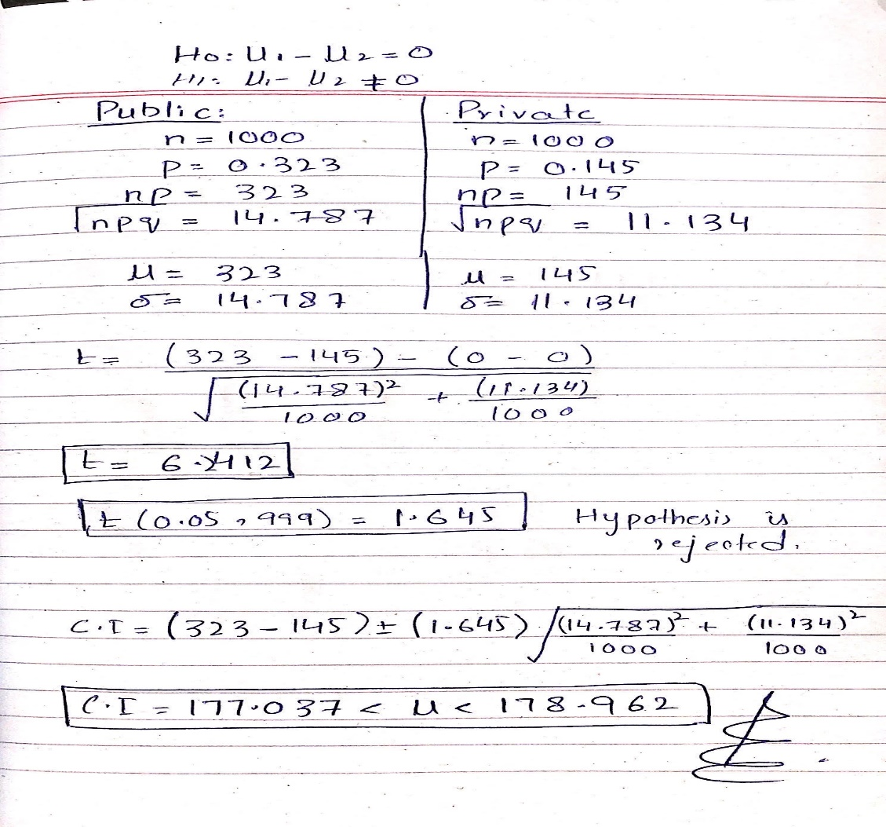

**Case Study 3: (Solution)**

1. 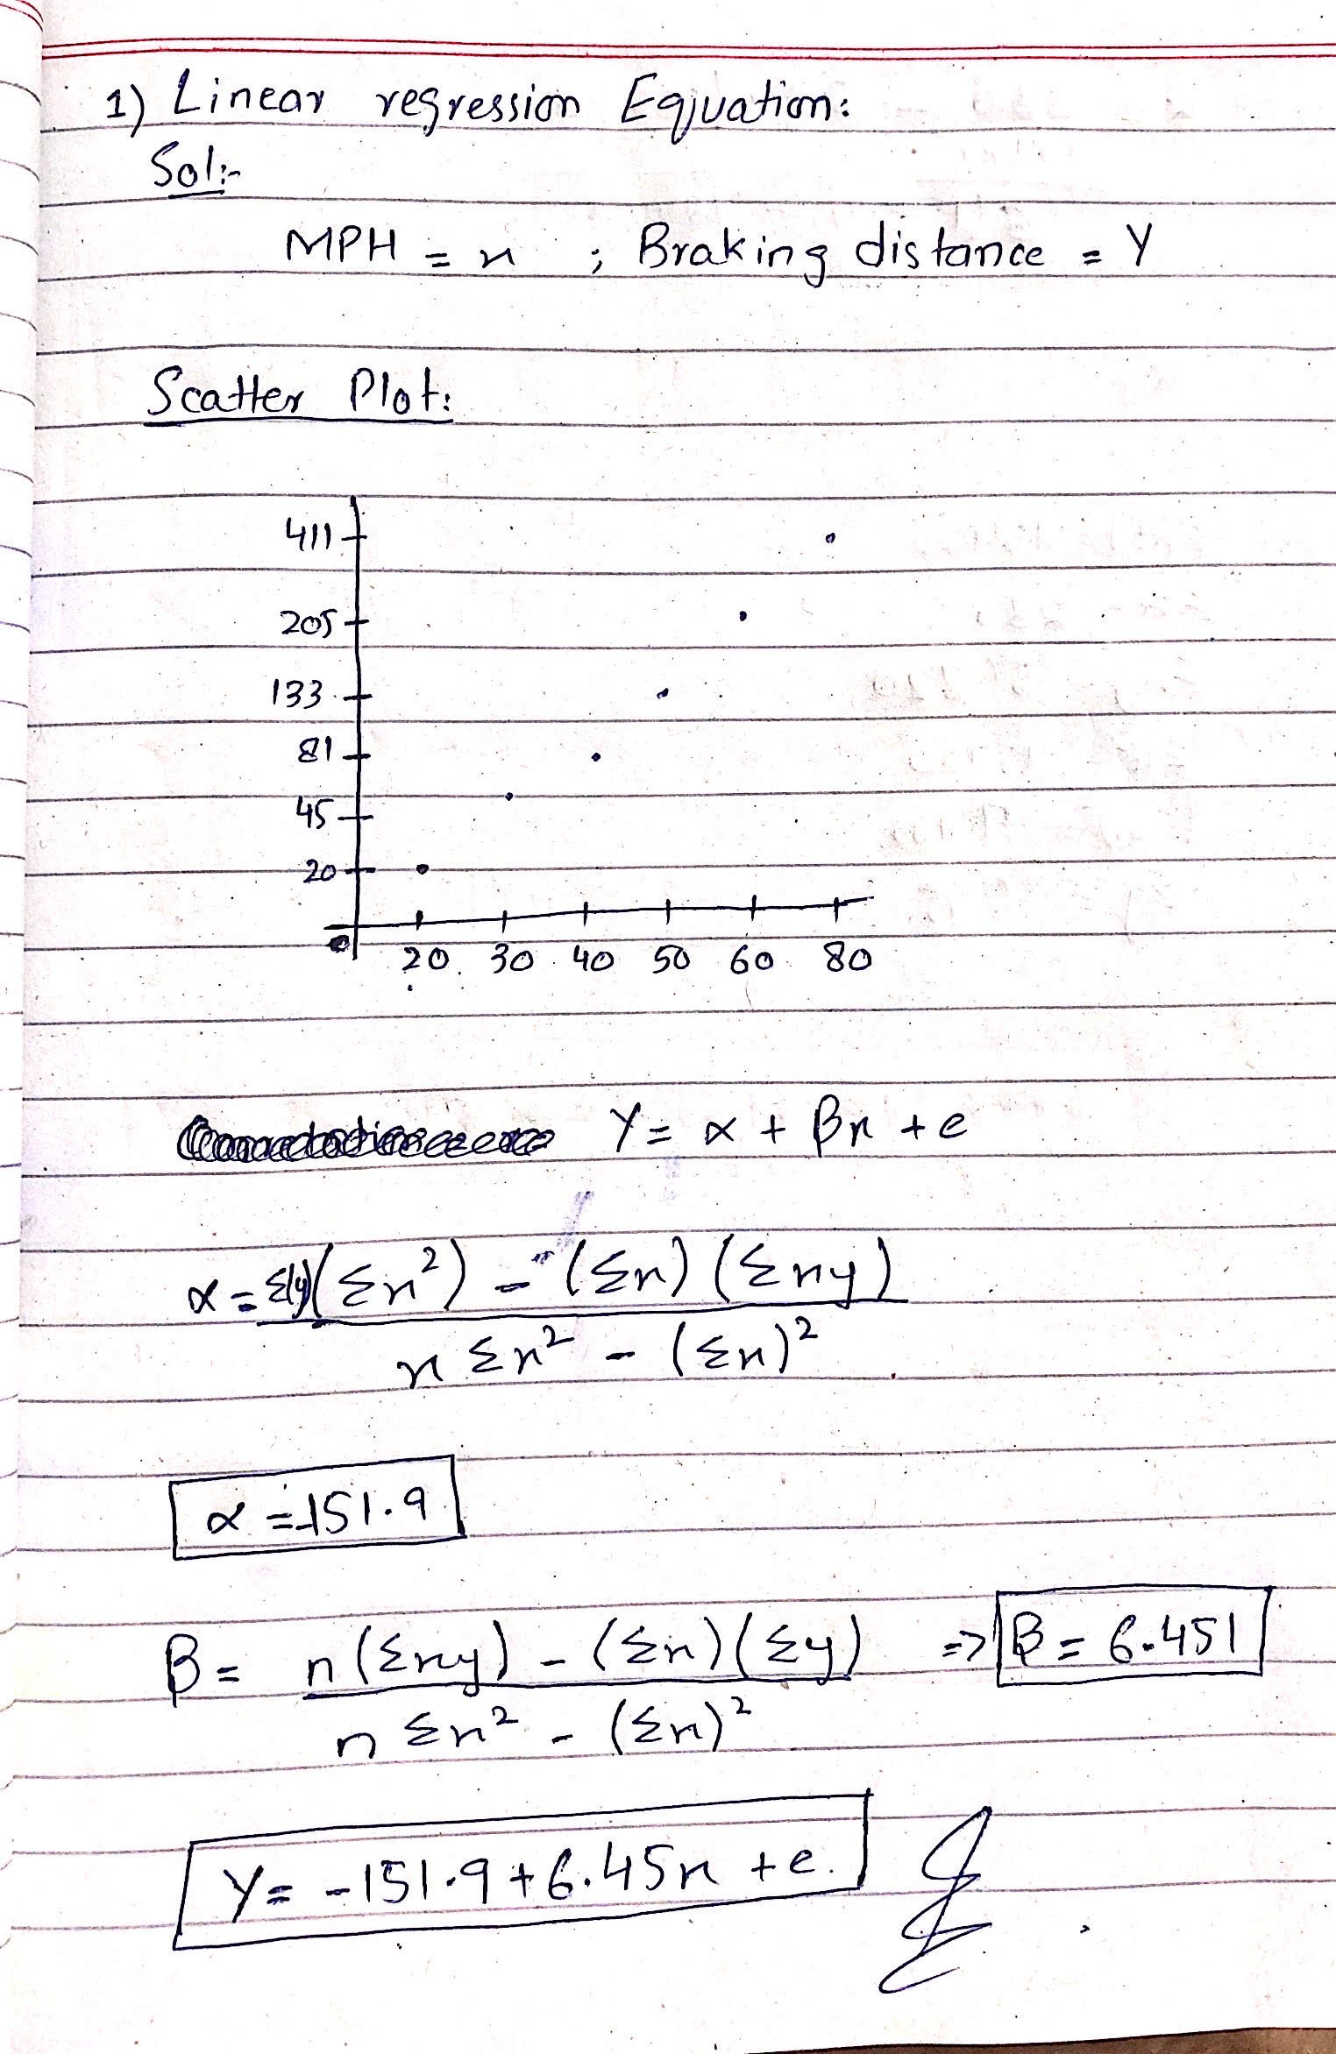
2. Slope tells that if the MPH of the vehicle is increased by one unit then, braking distance will be increased by 6.45 units.
3. At x=45, y=138.395
4. At x=100, y=492.2
5. Given data clearly states that if the MPH of the vehicle is greater than its braking distance will also be greater, which means braking distance is dependent of MPH and even it is directly proportional to MPH.

**Case Study 4: (Solution)**

**Data:**

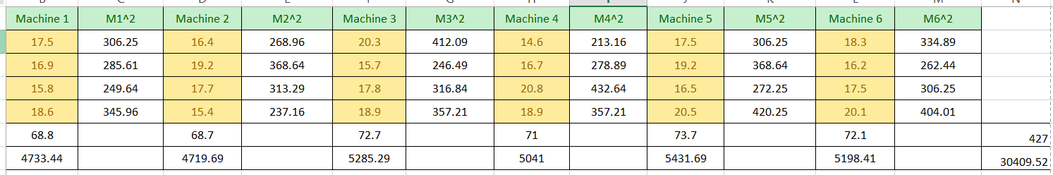

**C.F = (4272**)**/24 => 7597.04**

**SST = 7665.28 – 7597.04 => 68.24**

**SSTR = [(30409.52)/4 – 7597.14] => 5.24**

**SSE = 68.24 – 5.24 => 63**

**ANOVA Table:**

|  |  |  |  |  |
| --- | --- | --- | --- | --- |
| Source of Variation | D.F | Sum of Squares | Mean Square | F- Ratio |
| B/W Samples | 3 | 5.24 | 1.7467 | 0.554 |
| Within Samples | 20 | 63 | 3.15 |
| Total | 23 | 68.24 | 4.8967 | 0.554 |